

**System Specification**

**For Enhanced Solutions**

**Amateur Scientific Enduring Near-space Dirigible**

Table of Contents

1 Introduction 1

2 Project Blue Horizon System Requirements 4

2.1 Mission Objectives 4

2.2 Morse Decoder Requirements 5

2.3 Morse Decoder Processor Requirements 5

2.4 Morse Decoder Software Requirements 5

2.5 Mission Planning and Execution 5

2.6 Testing 6

2.7 Reliability 6

2.8 Training 6

2.9 Safety 6

2.10 Documents 6

2.11 Reviews 7

# Introduction

A Near Space Flight Program (NSFP) is one of the most technical challenging and rewarding endeavors that a multi-discipline team of engineers or hobbyists can undertake. Unlike projects with a one-year period of performance, an NSFP requires a multi-year commitment, incremental performance milestones, and a continuous capture of lessons learned with each successful flight leading to more complex missions and breakthrough goals.

The Project Blue Horizon Team would like to partner with Enhanced Solutions to achieve reliable Morse decoding.

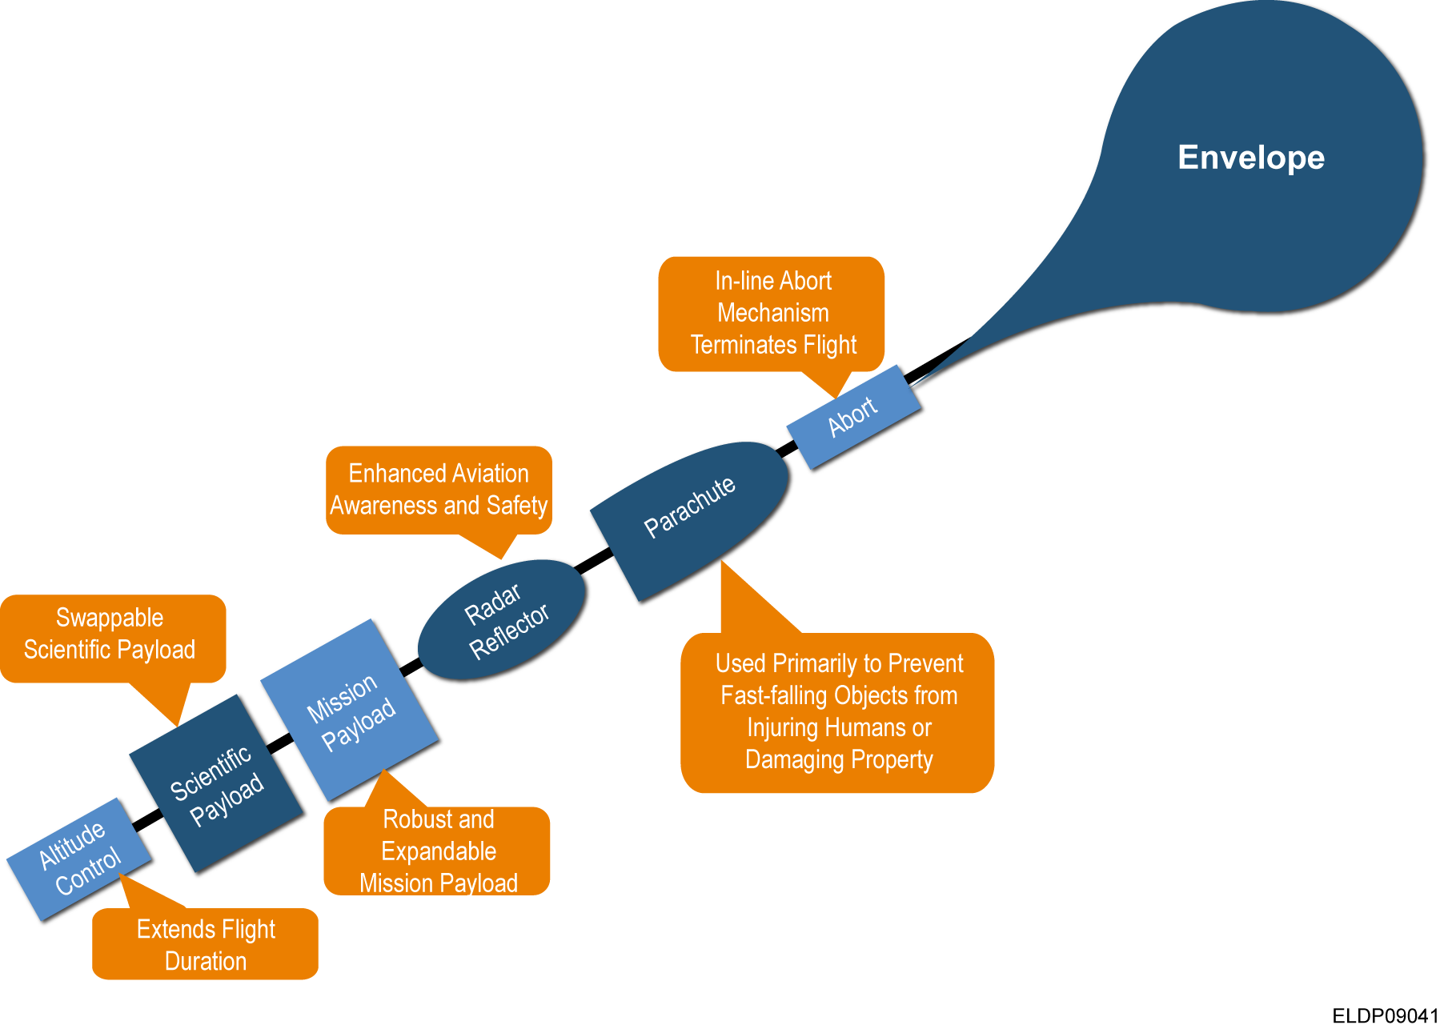

Figure : Project Blue Horizon Flight System

The current Morse decoder solution requires a 12dB signal to noise ration (SNR). Additionally all decoding processing is handled by the HF communications provider. The objective of this project is to increase decoding performance in a noisy environment by lowering the required SNR as well as moving the complexity of Morse decoding out of the HF provider.

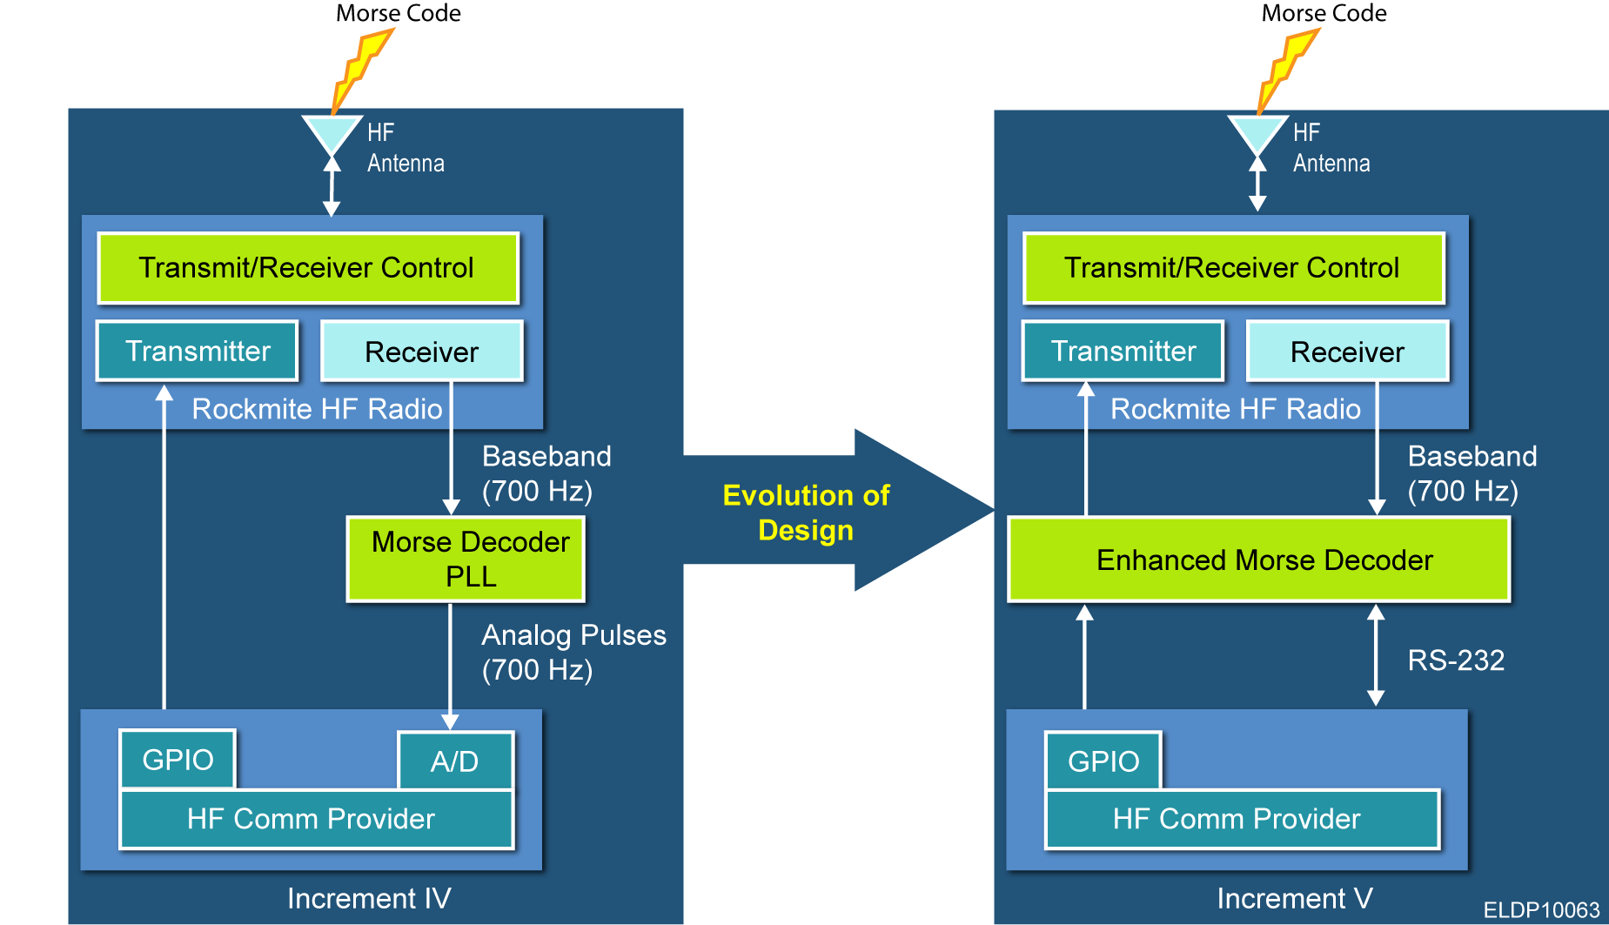

**Applicable Documents**

The Contractor **shall** be in full compliance with the appropriate segment of the following Federal Regulations:

* ***Federal Aviation Regulation FAR 101—MOORED BALLOONS, KITES, UNMANNED ROCKETS AND UNMANNED FREE BALLOONS***
* ***Code of Federal Regulation – Title 47, Telecommunication, Part 97 – Amateur Radio Service***

# Project Blue Horizon System Requirements

Above all else, the Enhanced Solutions Morse Decoder **shall** be planned, designed, developed, and executed to the following:

## Mission Objectives

|  |
| --- |
| The contractor **shall** plan, design, develop, and build a prototype Morse Decoder for ASCEND prior to Dec 10th, 2010. ASCEND will procure and assemble the Morse Decoder Boards. |
| The contractor **shall** plan, design, develop, and build a Morse Decoder for ASCEND prior to March 1st, 2011. ASCEND will procure and assemble the Morse Decoder Boards. |
| A minimum of one flight **shall** be conducted during PBH Year 5 with the Enhanced Solution Morse Decoder to demonstrate successful operations. |
| Mission simulations and/or rehearsal **shall** be performed with the Project Blue Horizon Team. |
| Enhanced Solutions, as control operators of portable or fixed amateur stations **shall** be properly licensed by the FCC for the frequency bands utilized for communications. |
| Enhanced Solutions **shall** submit a waiver with justification for any requirement that will not be met. |

## Morse Decoder Requirements

|  |
| --- |
| The Morse Decoder **shall** be designed using Eagle schematic and board layout tools. |
| The Morse Decoder **shall** be no more than two layers. |
| The Morse Decoder **shall** be less than or equal to 0.4 pounds. |
| The Morse Decoder **shall** decode Morse commands with a maximum signal to noise ratio of 6dB. |
| The payload **shall** be designed so that it can be easily re-assembled and tested within 5 calendar days. This will allow multiple missions in the same year and rapid manufacturing for repeat missions. Simplicity in the electrical and mechanical design is encouraged, both for manufacturing, reliability, and weight management. |
| The Morse Decoder **shall** be clearly marked on the Printed Wiring Board with the revision number and part number. |
| The Morse Decoder **shall** be manufacturable such that the printed wiring board and parts can be assembled by hand utilizing a soldering iron. |
| The Morse Decoder **shall** cost less then $55 per assemble board. |
| The Morse Decoder components **shall** operate to low temperatures of -40C. |

## Morse Decoder Processor Requirements

|  |
| --- |
| The Morse Decoder **shall** handle a minimum decode rate 18 Word-Per-Minute rate. |
| The Morse Decoder **shall** utilize an Analog to Digital converter (ADC) with minimum resolution of 10 bits. |
| The Morse Decoder **shall** utilize a micro-processor or digital signal processor. |
| The Morse Decoder **shall** utilize a processor with a minimum of 3kB of RAM (or SRAM). |

## Morse Decoder Software Requirements

|  |
| --- |
| The Morse Decoder **shall** perform the algorithm defined in the Morse Decoder Simulation, delivered by ASCEND to Enhanced Solutions prior to November 1st 2010. |
| Enhanced Solutions **shall** perform an analysis of the simulation to determine the minimum processor frequency utilizing (but not limited to):   1. Number of Filters Coefficients per filter 2. Number of Multiplies, Adds, and memory copies per filter coefficient 3. Sampling Frequency of ADC |
| Enhanced Solutions **shall** modify the Morse Decoder Simulation algorithm as needed to enable real-time implementation without compromising performance. |

## Mission Planning and Execution

|  |
| --- |
| Enhanced Solutions contractor **shall** identify and develop scenarios of potential in-flight anomalies. |
| Enhanced Solutions **shall** assist the contractor conduct a verbal walk through of “anomaly scenarios” at the Flight Readiness Review held prior to each flight using the Enhance Solution’s Morse Decoder. |
| Enhanced Solutions **shall** perform post-flight analysis of Morse Decoder performance using data supplied by ASCEND missions. |

## Testing

|  |
| --- |
| A complete test program **shall** be conducted to ensure that the Project Blue Horizon mission will be successful and achieve mission objectives. |
| The contractor **shall** conduct environmental testing to verify that the payload will function during the expected conditions that will be encountered during the mission. All environmental testing will be performed with the assistance of ASCEND team members and facilities. |
| Real-time pre-flight testing **shall** be performed to ensure that all systems are functional and the payload and ground segment(s) are communicating prior to launch. |
| The contractor **shall** use a customer approved Acceptance Test Procedure to conduct a formal system sell off. |
| Pre-flight test **shall** be performed with actual flight configuration hardware. |

## Reliability

|  |
| --- |
| Analysis **shall** be provided to determine the quantity and type of spare subsystems and components required to ensure pre-flight issue resolution so that planned missions are not canceled or delayed. |

## Training

|  |
| --- |
| Enhanced Solutions **shall** attend training along with the Project Blue Horizon team to ensure that there is no single-point-of-failure if a team member is unable to perform their assigned task(s). |

## Safety

|  |
| --- |
| Enhanced Solutions **shall** participate in all Safety related training required for flight missions. |

## Documents

|  |
| --- |
| Enhanced Solutions **shall** deliver SDRL 01 System Design Document (SDD) that defines the Morse Decoder design. |
| Enhanced Solutions **shall** deliver SDRL 02 Interface Control Document (ICD) that defines the messages transmitted between the Mission Payload and the Morse Decoder by December 10th 2010. |
| Enhanced Solutions **shall** deliver SDRL 03 Verification Cross Reference Matrix (VCRM) due October 15th 2010. |
| Enhanced Solutions **shall** deliver SDRL 04 System Test Plan prior to November 24th 2010. |
| Enhanced Solutions **shall** deliver SDRL 05 System Test Procedures (STP) that defines the Morse Decoder tests performed during pre-flight checks 3 days prior to Test Readiness Review. |
| Enhanced Solutions **shall** deliver SDRL 06 Acceptance Test Procedure (ATP) that defines the Scientific Payload tests performed to show compliance to testable requirements in this specification prior to system delivery. |
| Enhanced Solutions **shall** deliver an integrated plan for review by ASCEND prior to October 29th 2010. |
| Enhance Solutions **shall** deliver the following hardware documents for the Morse Decoder Board   1. Schematic 2. Board Layout File 3. Gerber Files 4. Parts list – Columns includes Reference Designator, Part Number, Part Description, Qty, Link to Vendor website (Digikey,Newark,ect..), Estimated price, |

## Reviews

|  |
| --- |
| Enhanced Solutions team **shall** participate in the following reviews, dates with the ASCEND team:   1. Internal Preliminary Design Review – November 5th 2010 2. Internal Critical Design Review – December 10th 2010 3. Internal Test Readiness Review – February 18th 2011 4. Internal Flight Readiness Reviews – Beginning of April |
| Enhanced Solutions **shall** participate in the following reviews, dates to be determined (TBD), with the ASCEND team and the Blue Horizon Corporation (BHC):   1. ASCEND’s Internal Preliminary Design Review – End of October 2. Critical Design Review – Middle of December 3. Test Readiness Review* – Middle of January 4. Flight Readiness Review – Beginning of April   * *Optional* |